MPA 634  
Data Science and R for Administrators  
Homework #3

Geometric Objects

1. Problem 6 from Exercises 3.6.1

Recreate the plots shown

# Code for 3.6.1 problem 6

ggplot(data = mpg, mapping = aes(x = displ, y = hwy)) +

geom_point() +

geom_smooth(se = FALSE)

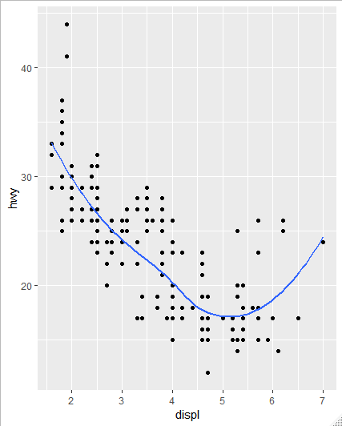

ggplot(data = mpg, mapping = aes(x = displ, y = hwy)) +

geom_point(mapping = aes(color = drv)) +

geom_smooth(se = FALSE, mapping = aes(color = drv))

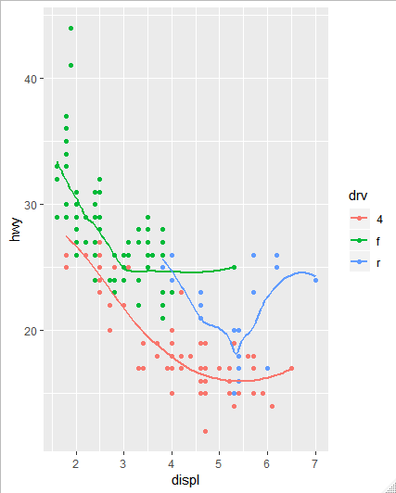

ggplot(data = mpg, mapping = aes(x=displ, y = hwy)) +

geom_point(mapping = aes(color = drv)) +

geom_smooth(se = FALSE, mapping = aes(linetype = drv))

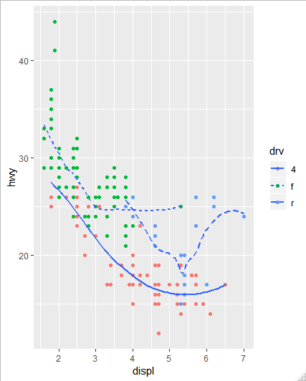

ggplot(data = mpg, mapping = aes(x = displ, y = hwy)) +

geom_point()+

geom_smooth(se = FALSE, mapping = aes(group = drv))

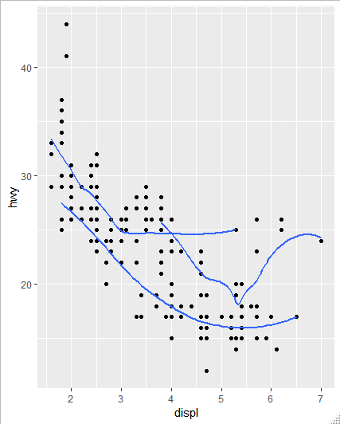

ggplot(data = mpg, mapping = aes(x = displ, y = hwy)) +

geom_point(mapping = aes(color = drv)) +

geom_smooth(se = FALSE)

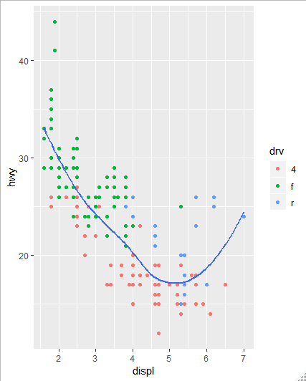

ggplot(data = mpg, mapping = aes(x = displ, y = hwy)) +

geom_point(color = "white", size = 4) +

geom_point(mapping = aes(color = drv))

